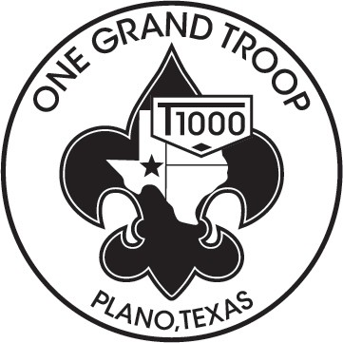
Troop 1000 “One Grand Troop”

Scouting <Name of Event> Permission Slip
I understand that participation in the activity involves a certain degree of risk. I have carefully considered the risk involved and have given consent for myself or my child to participate in the activity. I understand that participation in the activity is entirely voluntary and requires participants to abide by applicable rules and standards of conduct. I release the Boy Scouts of America, the local council, the activity coordinators, and all employees, volunteers, related parties, or other organizations associated with the activity from any and all claims or liability arising out of this participation.
Please retain the top half of the form and return the remainder to the Troop.

COST: Food $ 0
Gas $ 0
Camping $ 0
--------
TOTAL $ 0 (Please note that payment should be cash only in exact bills)

What: <Name of event>
Where: <Put where the event is taking place>
When: (Scouts must be at the church by 6:00 pm, Friday)
This is a TWO night campout!
Departure Date: | Friday, <departure date> | Time: | <depart time>
Return Date: | Sunday <return date> | Time: | <return time>

Equipment required:

Standard BSA backpacking equipment (See troop web site) and COLD WEATHER GEAR
- Day pack
- Sturdy, broken-in hiking boots or athletic shoes
- Rain gear (no ponchos)
- Travel Uniform – Field Uniform (with neckerchief & troop hat)
- In camp Uniform – Activity Uniform (BSA T-shirts)
- 2 quarts of water
- Personal First Aid Kit
- BSA Handbook

NOTE: TENT MUST BE PACKED IN THE SCOUT’S PACK!
In Case of Emergency (The following are points of contact between the Troop and all others during the event) Primary Contact: Becky Smith Phone: 214.457.0465 Secondary Contact: Sallie Diamond Phone: 469.644.0169

Fill out bottom half completely. Tear along dotted line and return to the Troop.
- - - - - - - - - - - - - - - - - - - - - - - - - - - - - - - - - - - - - - - - - - - - - - - - - - - - - - - - - - - - - - - - - - - - - - - - - - - - - - - - - - - - - - - - - - - - - - - - - - - - - - - - - -

Event Name: <Event Name> Departure: <depart date> Return: <Return date>
PLEASE PRINT

Scout’s Name: __________________________________________________________ Scout’s Patrol: _____________________________
has my permission to participate in the following event with BSA Troop 1000.
**Please CHECK the preferred Sunday afternoon number**. – Phone numbers also used for return calling – “neatness counts”

Parent’s phone number: Home:
Cell:
Alternate:

Additional Emergency Contact: Name: Phone:

Parent’s Signature: Date:

TROOP CONTACT’S COPY (To be detached by TROOP SCRIBE)
- - - - - - - - - - - - - - - - - - - - - - - - - - - - - - - - - - - - - - - - - - - - - - - - - - - - - - - - - - - - - - -

Scout’s Name: __________________________________________________________ Scout’s Patrol: _____________________________

has my permission to participate in the following BSA Troop 1000 event.

Parent’s phone number: Home: Cell: Alternate:

Event Name: <Event Name> Departure: <depart date> Return: <Return date>

I (the parent or legal guardian of the Scout indicated above) hereby authorize Dale Leonard or other registered adult leader of Troop 1000 to consent to medical treatment for my child in case of accident or illness when I am not present with my child and to discuss information regarding such treatment with the medical provider. I understand that reasonable effort will be made to contact me before such action is taken but that contact is not required for consent. I will assume financial responsibility for emergency care if such is not fully covered by Boy Scouts of America Accident Insurance. I have read and understand this permission slips information.

Parent’s Signature: Date:
SCOUTMASTER’S COPY (To be detached by the TROOP SCRIBE) PS20151014.doc

