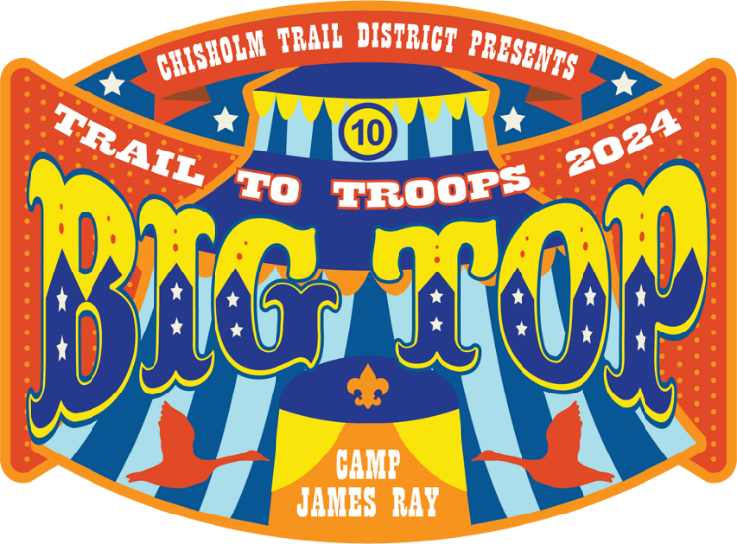

Trail To Troops
Hosted by Chisholm Trail District
September 27- 29, 2024
Camp James Ray

EVENT SCHEDULE

Friday 6:00 p.m. Units may begin checking in at the Dining Hall
9:00 p.m. Scoutmaster/Volunteer/Staff Meeting
11:00 p.m. Lights out

Saturday 9:00 a.m. Activities open
12:00 p.m. Activities close
12:00 p.m. Lunch
1:00 p.m. Activities open
4:00 p.m. Activities close
4:00 p.m. – 7:00 p.m. Free time, Dinner
7:00 p.m. Happy Hour/ Ice Cream Social/ Awards
10:00 p.m. Lights out

Sunday 10:00 a.m. Units check out

NOTE: Please contact an Event Staff member to request a campsite inspection prior to checking out. A signed checkout form is required for event patches.

All staff/volunteers/participants are encouraged to dress up
in costumes, face paint, silly hats, etc!

Extra points for patrols dressed up!

COSTS:

- Youth Participants/Prospective Scouts:
  - Early bird $25 before September 1 at 11:00 p.m.
  - $30 after September 1 at 11:00 p.m.
- Adults/Parents of Prospective Scouts:
  - Early bird $10 before September 1 at 11:00 p.m.
  - $15 after September 1 at 11:00 p.m.
- Staff/volunteers:
  - Early bird $10 before September 1 at 11:00 p.m.
  - $15 after September 1 at 11:00 p.m.
- Staff/volunteer food cost: additional $10 if eating with staff in the dining hall (see Food section below).

Food:

- Packs/Dens will be responsible for bringing/preparing their own food for the entirety of the event.
- Troops will not be providing meals/food to Packs/Dens.
- Staff and volunteers have the option to eat with their Troop or purchase a meal package to eat with staff in the dining hall.
  - Dining hall meal package: $10
  - Staff and volunteers purchasing the meal package MUST register in Black Pug as eating with staff and indicate allergies, dietary restrictions, and which meals you will eat with staff.
  - Meal options: Saturday breakfast, lunch, dinner; and Sunday breakfast
- All staff and volunteers are responsible for their own food on Friday night

PACK INFORMATION

- Registrations:
  - Registrations may be entered by the Pack for everyone or individuals may register themselves
  - All individual registrations will be grouped at the Pack level for the event by the event staff
- Camping:
  - Packs will have the option to camp Friday and/or Saturday
    - Please indicate in Black Pug if you are camping and which nights you will be staying
  - Please note that you may not be the only Pack in a campsite. While we will do our best to limit the number of people per site, please consolidate your group the best you can within the campsite to allow room for others.
  - Gates will be open during non-event times in order to drop off gear, if needed. Driving around at camp will NOT be allowed during event times to ensure everyone’s safety. Please unload your gear and return the car to the parking lot. ONLY cars for families with special needs will be allowed to be parked at the campsite. A special needs parking pass MUST be obtained from Event Staff during check in.
- Cooking:
  - Packs will need to prepare their own food. Please make sure all your families know so your Pack is not left hungry!
  - All Packs may prepare food at their campsites.
  - Those attending for the day only may bring sack lunches/dinner
  - Meals will not be provided by district during this event for Packs.
  - An ice cream treat will be provided on Saturday evening at the social.
- Rotations/Activities:
  - There will be a specified rotation schedule for the various activities which will be given at check in.
  - Midway with games, activities, food will be available in a come and go manner for the duration of the activities.
- Activities include:
  - Target Sports:
    - BB
    - Archery
    - Wrist Rockets/Sling Shots
  - Pancake Toss & First Aid
    - NOTE: Bonus points awarded for participants having personal First Aid Kits and knowing how to use each item included
  - Obstacle Course
  - Fire Building
- Midway:
  - Corn Hole, Giant Connect Four, and more!
  - Free popcorn and cotton candy.
- Ice Cream Social:
  - At 7:00 p.m. on Saturday, participants, volunteers, and staff will all meet at the Activity Center pavilion by the camp Trading Post (large building near flag poles). All units are encouraged to attend and use this time to socialize and enjoy the treat.
  - Chisholm Trail District will provide ice cream/frozen treats to all.
  - Awards will be handed out at the Social.
  - In lieu of a formal campfire program, skits, songs, etc. preapproved by event staff are encouraged.
- Health forms:
  - All participants, youth and adult MUST turn in a current annual health form that expires after September 29, 2024. This must be turned into HQ at time of check-in with other required forms.
  - Health forms will be returned to the units upon check-out at HQ.
  - Any health forms not picked up at HQ will be shredded after completion of the event.
- Check-out:
  - Packs will be responsible for cleanup of their assigned campsite. Ensure your Pack portion of the campsite is clean. Camp Commissioners will inspect each campsite. Then, you will need to go to HQ (Dining Hall) to collect your event patches as you leave camp.
  - Participants NOT camping will still need to check out with event staff in the Dining Hall to receive patches, pick up Med Forms, and keep track of who is at camp.

TROOP VOLUNTEER INFORMATION

- Registrations:
  - Registrations may be entered by the Troop for everyone, or individuals may register themselves.
  - Units may register 6 youth and 3 adults starting July 1st.
  - Registration is open to all who wish to volunteer starting August 1st.
- Volunteer needs:
  - Activities:
  - Target and Range Activities:
    - Lead: Dan Brummer
    - BB
      - 4 - 8 youth/2 - 4 adults
      - All adults need NRA certification
      - Youth volunteers MUST have the Rifle Merit Badge
    - Archery
      - 4 - 8 youth (all MUST have Archery Merit Badge)
      - 2-4 Adults
    - Wrist Rockets/Sling Shots
      - 4 youth/2 Adults
  - Den Chief/Patrol Leader:
    - 8 - 10 youth, preferably older/experienced Scouts to accompany Cub Scouts throughout the day
  - Floating/Utility Staff:
    - 8 - 10 youth/4 - 5 adults to be available as runners/subs
  - Midway staff
    - number TBD
  - Pancake Toss/First Aid
    - Leads: Eric Meyler/Robynn Connors
    - 2 stations for each
    - 4 youth/2 adult volunteers total for combined activity
  - Obstacle Course
    - Lead: Chris Sherrod
    - 2 Stations
    - 4 youth/2 adult volunteers
  - Fire Building
    - Lead: Bev Williams
    - 8 stations
    - 8 youth/4 adults
- Volunteers will be mixed into 2 youth/1 adult groups and assigned stations
  - No one troop will run a single station
  - Allows all troops represented to have equal opportunities
- A movie night/video game tournament will be available on Saturday night in the dining hall for volunteers as a thank you.
- Volunteers are NOT required to camp.
- Volunteers are required to be in camp on Saturday from 7:00 a.m. to 5:30 p.m. to assist with setup, event, and clean up.
  - Please indicate during registration if the volunteer is camping or coming for the day only.
- Volunteers have the choice to bring/prepare their own food or pay for food prepared in the dining hall
  - See Food section above (page 2)
- Service hours for volunteers NOT offered by event staff. This is up to each individual troop to allow/disallow and sign off.
- OA service hours allowed. See Nick Clark to get hours signed off.
- Volunteer Hosted Activity:
  - Please indicate your top 3 choices for your volunteer assignment. Event staff will assign volunteers on a first come, first serve basis ensuring at least 2 members of each troop and 1 adult leader are placed together.
  - How to run the activity and where to get supplies will be discussed at the SPL/Staff meeting Friday night.
    - Activity-specific Zoom meetings will be held starting in August
  - Activity supplies will be provided by the district.
  - All activities should be completely set up and ready for visitors no later than 9:00 a.m. on Saturday.
  - Scoring method for each activity will be discussed in the activity meetings.
- Camping:
  - Troop volunteers can camp Friday and Saturday.
  - All volunteers will be consolidated into 1-2 campsites.
  - Gates will be open during non-event times to drop off gear, if needed. Driving around at camp will NOT be allowed during event times (safety issue). Please unload your gear and return the car to the parking lot. ONLY a tow vehicle with Troop Trailer and cars for families with special needs will be allowed to be parked at the campsite. A special needs parking pass MUST be obtained from Event Staff during check in.
- Cooking:
  - Troop volunteers have the option to cook in their campsites or eat in the dining hall.
  - Meals will be provided by District during this event for volunteers who register as eating with staff during registration (additional $10 fee). If eating with staff, please indicate which meals during registration.
- Health Forms:
  - All participants, youth and adult MUST turn in a current annual health form that expires after September 29, 2024. This must be turned into HQ at time of check-in with other required forms.
  - Health forms will be returned to the units upon check out at HQ.
  - Any health forms not picked up at HQ will be shredded after completion of the event.
Troop Socials:
- Social Gathering:
  - At 7:00 p.m. on Saturday, participants, volunteers, and staff will all meet at the Activity Center pavilion by the camp Trading Post (large building near flag poles). All units are encouraged to attend and use this time to socialize and enjoy the treat.
  - Chisholm Trail District will provide ice cream/frozen treats to all.
  - Awards will be handed out to Cub Scouts at the Social.
  - In lieu of a formal campfire program, skits, songs, etc. preapproved by event staff are encouraged.
  - Volunteers may bring a Troop History Board to display at the Ice Cream Social:
    - Displays such as used at Meet the Troops or Camporee
    - Flyers are allowed
    - This will be PASSIVE recruiting, no aggressive recruiting please. Allow Cubs Scouts to come to you.
- Check-out:
  - Volunteers will be responsible for cleanup of their assigned campsite. Ensure your portion of the campsite is clean. Camp Commissioners will inspect each campsite. Then, you will need to go to HQ (Dining Hall) to collect your event patches as you leave camp.
  - Volunteers NOT camping will still need to check out with event staff in the Dining Hall to receive patches, pick up Med Forms, and keep track of who is at camp.

